Who does big team science?

Abstract

This paper examined the nature of publications in Big Team Science (BTS): large-scale collaborations between multiple researchers at multiple institutions. These projects can improve research by initiating collaborations that span across the globe, age groups, education levels, and subfields of research. As the number of BTS publications increase, it is useful to explore who is currently involved in BTS projects to determine diversity in both research subject and researcher representation. We examined the diversity of BTS publications and authors across more than half a million articles to investigate where and what is currently published, and author characteristics including differences in career length, publication metrics, affiliation, and affiliation geopolitical regions. Interestingly, BTS publications are increasingly dominated by early career researchers from WEIRD geopolitical regions with Health and Physical Science accounting for the majority of BTS articles. However, the increase in preprints, BTS articles, and non-WEIRD authors across time demonstrate the efforts of the science community to diversify its researchers.

*Keywords:* big team, science, authorship, credit

Who does big team science?

According to the Oxford English dictionary, collaboration is two or more people working together to achieve a certain goal (OED, 2016). Collaboration in scientific endeavors involves multiple researchers at (potentially) multiple institutions to communicate and work together to advance knowledge in their chosen field. Collaboration can manifest uniquely in each project dependent on the skill sets, hypotheses, and perspectives of collaborators. While collaboration is not new in science, the current interest of “big team science” is increasing (Coles et al., 2022; Forscher et al., 2022; N. Stewart et al., 2017). Big team science projects and/or organizations utilize and run on large-scale collaboration to ensure that diverse populations and ideas are brought into research projects, which in turn allows for more reliability and generalizability in the results and method of the study.

BTS appears to be expanding as a result of two sources: 1) increasing globalization and technology that allows for real-time interdisciplinary research, and 2) expanding interest in reproducibility, replication, and generalizability (Maxwell et al., 2015; Nelson et al., 2018; Zwaan et al., 2018). Technological advances have provided easier ways to collaborate with people who are from other universities and countries through document sharing platforms (e.g., Google, GitHub, and the Open Science Framework), video chatting platforms (e.g., Zoom, Microsoft Teams), and messaging and project management platforms (e.g., Slack, Trello, when2meet, etc.). The credibility movement seems to suggest that by having both collaborations that span across the globe and subfields of research areas, age groups, and education levels should help to drive science in the path of better materials, reliability, generalizability and more robust sample sizes (when necessary) in a study (Auspurg & Brüderl, 2021; LeBel et al., 2018; Nosek & Lakens, 2014a).

The credibility movement was originally defined by a focus on large scale replications used in collaborative environments (Vazire et al., 2022). Generally, the movement appears to have been driven by early career researchers (i.e., those who are within five years of their first appointment) (Maizey & Tzavella, 2019); however, there are no large meta-scientific investigations on this specific topic to date. Potentially, the lack of investigation is tied to the newness of the large-scale research in many fields, as it is only in recent years that publications like the Open Science Collaboration (Open Science Collaboration, 2015), Many Labs Collaborations (Buttrick et al., 2020; Ebersole et al., 2016, 2020; Klein et al., 2018; Klein et al., 2022; Mathur et al., 2020; Skorb et al., 2020) or the first papers from the Psychological Science Accelerator (Bago et al., 2022; Buchanan et al., 2023; Dorison et al., 2022; B. C. Jones et al., 2021; Moshontz et al., 2018; Psychological Science Accelerator Self-Determination Theory Collaboration, 2022; Wang et al., 2021). Generally, the researcher incentive for replication and/or involvement in big-team projects was low for three reasons. First, journals often prioritize “novel” or new results which led to rejection of replication manuscripts and publication bias (Franco et al., 2014; Hubbard & Armstrong, 1997; Nosek et al., 2012). Second, the “failure” to replicate was often placed on the replication team as “bad science” rather than a careful consideration of publication biases and (potential) questionable research practices (Klein et al., 2022; Maxwell et al., 2015). Last, why should someone want to spend time and resources on an answer we already “know” (Isager et al., 2021, 2023)?

However, the success and interest in the large-scale reproducibility projects (Errington et al., 2021; Open Science Collaboration, 2015), paired with the meta-scientific publications focusing on researcher practices and incentive structures (John et al., 2012; Silberzahn et al., 2018) led to a change in journal guidelines and incentives for researchers interested in participating in large-scale replication studies (Grahe, 2014; Kidwell et al., 2016; Mayo-Wilson et al., 2021; Nosek et al., 2015). In some fields, the replication movement demonstrated that large-scale teams were a practical (and publishable) solution to answering research questions in generalizable way. The support for Registered Reports, papers accepted before the data has been collected (Nosek & Lakens, 2014b; S. Stewart et al., 2020), has allowed researchers to invest in projects that they know should be published when the project is complete. Further, the implementation of the Transparency and Openness Guidelines (Nosek et al., 2015) and the Contributor Role Taxonomy (CRediT) system (Allen et al., 2019) have pushed journals and researchers to promote more open, inclusive publication practices.

Beyond the replication movement, the credibility movement has mirrored calls for diversification or de-WEIRDing (e.g., Western, Educated, Industrialized, Rich, and Democratic) scientific research (Henrich et al., 2010; Newson et al., 2021; Rad et al., 2018) by improving representation in research samples. Like the large-scale studies in Physics (“A Philosophical Case for Big Physics,” 2021; Castelnovo et al., 2018) and Biology (Collins et al., 2003), the Social Sciences struggle to represent the breadth of humanity across both researcher and population characteristics. Now, grassroots organizations, such as the Psychological Science Accelerator (Moshontz et al., 2018), ManyBabies (<https://manybabies.github.io/>), NutNet (<https://nutnet.org/>), and DRAGNet (<https://dragnetglobal.weebly.com/>) can begin to tackle these issues by recruiting research labs from all over the globe to provide diversity in geographic, linguistic, and researcher representation. Publications have examined the global understanding of morality, face processing, COVID-19 information signaling, and more (Bago et al., 2022; Dorison et al., 2022; B. C. Jones et al., 2021; Psychological Science Accelerator Self-Determination Theory Collaboration, 2022; Van Bavel et al., 2022; Wang et al., 2021). While these organizations and one-time groups for BTS studies have provided an incredible wealth of data for the scientific community, we do not yet know exactly *who* is involved with, and benefits from, the BTS and credibility movement. Publications on BTS generally explore challenges, lessons learned, and the need for BTS (Coles et al., 2022; Forscher et al., 2022).

Therefore, the goal of this manuscript is to examine both the *publications* and *people* involved in BTS projects. We present descriptive information about the publication sources and types of articles that we classified as BTS projects to demonstrate what areas of research show large-scale research. Next, we examine the individuals involved in those projects for descriptive and predictive purposes. To describe the people involved in BTS projects, we used education, types of publications (i.e., articles, preprints, books, etc.) from BTS individuals, and publication metrics.

For predictive statistics, we explored the change in diversity of authors over time. We see an increasing interest and number of publications in BTS but we do not yet know if this uptick in large-scale projects has diversified the *people* involved in BTS. While a few publications have noted that BTS appears to be early career researchers (Maizey & Tzavella, 2019), no one has systematically investigated this perception. Further, it is unclear if the focus of de-WEIRDing science has only focused on the representation of the research participants or if it has also improved the representation of researchers outside of North America and Europe. Last, who runs these BTS projects? Do we see an increase in diversity for the authors who generally receive the most credit for these projects (i.e., first several author(s) and last author)? As hiring and promoting practices often place a heavy weight on publications and especially “influential” publications, it becomes necessary to critically examine the representation present in authorship in BTS projects.

# Research Questions

* Research Question 1: What publication sources publish big team science papers?
* Research Question 2: What are the types of articles that are being published in big team science?
* Research Question 3: Who is involved in big team science?
* Research Question 4: How has the diversity of those involved in big team science changed over time?

This manuscript was preregistered with the same conceptual ideas using Google Scholar and ORC-ID databases (MASKED FOR REVIEW[1]) but then was updated with access to the Scopus database for a broader picture of BTS projects (MASKED FOR REVIEW). All materials and code can be found on our OSF page: MASKED FOR REVIEW or corresponding GitHub archive: MASKED FOR REVIEW.

# Method

## Publications

We have defined BTS publications as publications with at least ten authors at ten different institutions that were published in peer-reviewed journals or had posted a full paper pre-print. While this definition is a somewhat arbitrary choice, we separate this research from research on team science that uses any multi-university collaboration as a definition (B. F. Jones et al., 2008) to focus on larger sized teams rather than teams of any size. With at least ten institutions, the complexities of infrastructure, resources, tenure and promotion policies, ethics review, and more can occur (Forscher et al., 2022). Therefore, we believe this choice selects publications that would be “big” teams and those potential obstacles.

We used data from 1970 and forward in the Scopus database, as it is noted online that this time period includes cited references for calculation of several of our variables described below. We will analyze our results based on four subject areas present in the Scopus database: Physical Sciences, Health Sciences, Social Sciences, and Life Sciences. We filtered the database to include articles, articles in press, business articles, conference papers, data papers, preprints, and surveys using Elsevier’s classification system. This project was supported by access to the Scopus database through the International Center for the Study of Research.

## Data Curation

### RQ1: Publisher Information.

We extracted the following information for publication sources: the name of the publication (source title), subject area (both the large four subject areas and the smaller four digit all science journal classification [ASJC] code), and the journal impact using the Source Normalized Impact per Paper (SNIP).

### RQ2: Publication Information.

For each publication of the identified BTS publications, we examined the full four digit ASJC subject areas codes for each of the larger four subject areas and the keywords present for these publications.

### RQ3: Author Descriptive Statistics.

The author list was extracted from each publication. Next, we used the author and affiliation arrays to curate a list of all publications and author information included in BTS papers to calculate the variables described below.

#### Education.

We collected degree information from the author table. Information on this variable is in the appendix.

#### Types of Publications.

We took information from the publication type variable for each author’s publications to present information about the types of papers BTS authors publish. Information on this variable is in the appendix.

#### Publication Metrics.

For each author, we calculated the number of publications and the h-index. The h-index represents the highest *h* number of publications that have at least *h* citations.

#### Institutions.

We report the number of institutions involved in big team science publications.

### RQ4: Author Diversity Statistics.

#### Seniority.

Career length for each author was defined as the year of the first publication minus the current year listed for each author. Number of publications included the number of unique entries an author was included in the database. Career length and number of publications was used as a proxy for the “age” or “seniority” of a scholar.

#### Geopolitical Region.

Geopolitical region was created by binning country code identifiers into the 17 identified United Nation subregions.

# Results

We used the 95% confidence interval to make decisions on predictor or effect size differences from zero. The confidence interval that does not include zero would be considered different from zero (to four decimal places). We made no directional predictions.

## RQ1: Publisher Information.

### Number of articles.

The total number of articles included in this analysis was 510334 including 445301 Health Sciences articles, 228194 Physical Sciences articles, 26652 Social Sciences articles, and 307514 Life Sciences articles. Articles could be classified into multiple categories. Figure 1 shows the number of articles published across time for each of the four large subject areas.

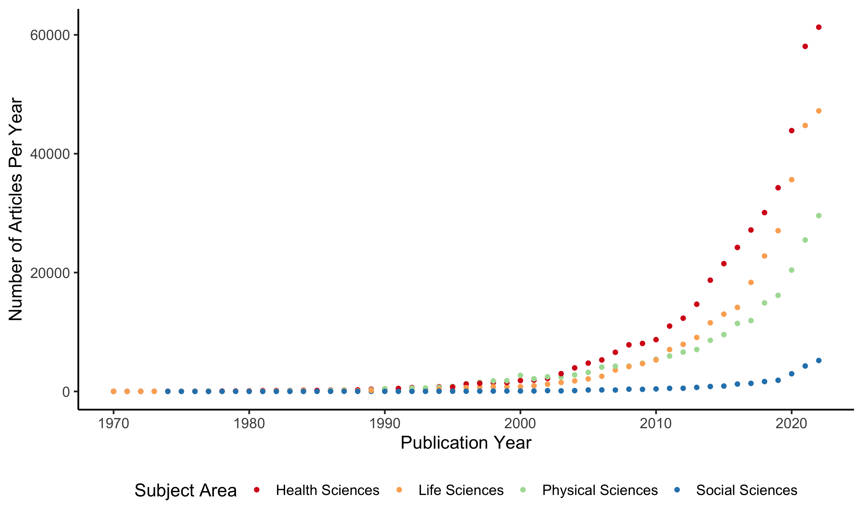

Figure 1: Number of big-team science publications separated by four large subject areas across years. All four subject areas show an exponential number of publications in the last decade.

### Number of journals.

The number of distinct journals big team science articles were published in was 14924 with 6559 journals in Health Sciences, 5787 journals in Physical Sciences, 2500 journals in Social Sciences, and 4187 journals in Life Sciences. The descriptive statistics for the Source Normalized Impact per Paper is presented in the supplemental materials with a comparison for all papers.

## RQ2: Publication Information.

Publication interest area was summarized by the four large subject areas creating a word cloud plot of the total number of publications within the ASJCs. Figure 2 displays that the Health Sciences tends to publish within medicine and oncology, with a corresponding focus of cancer research and genetics for the Life Sciences. The Physical Sciences was mostly dominated by physics research, chemistry, and ecology. The BTS publications in the Social Sciences are mostly within psychology, education, and health.

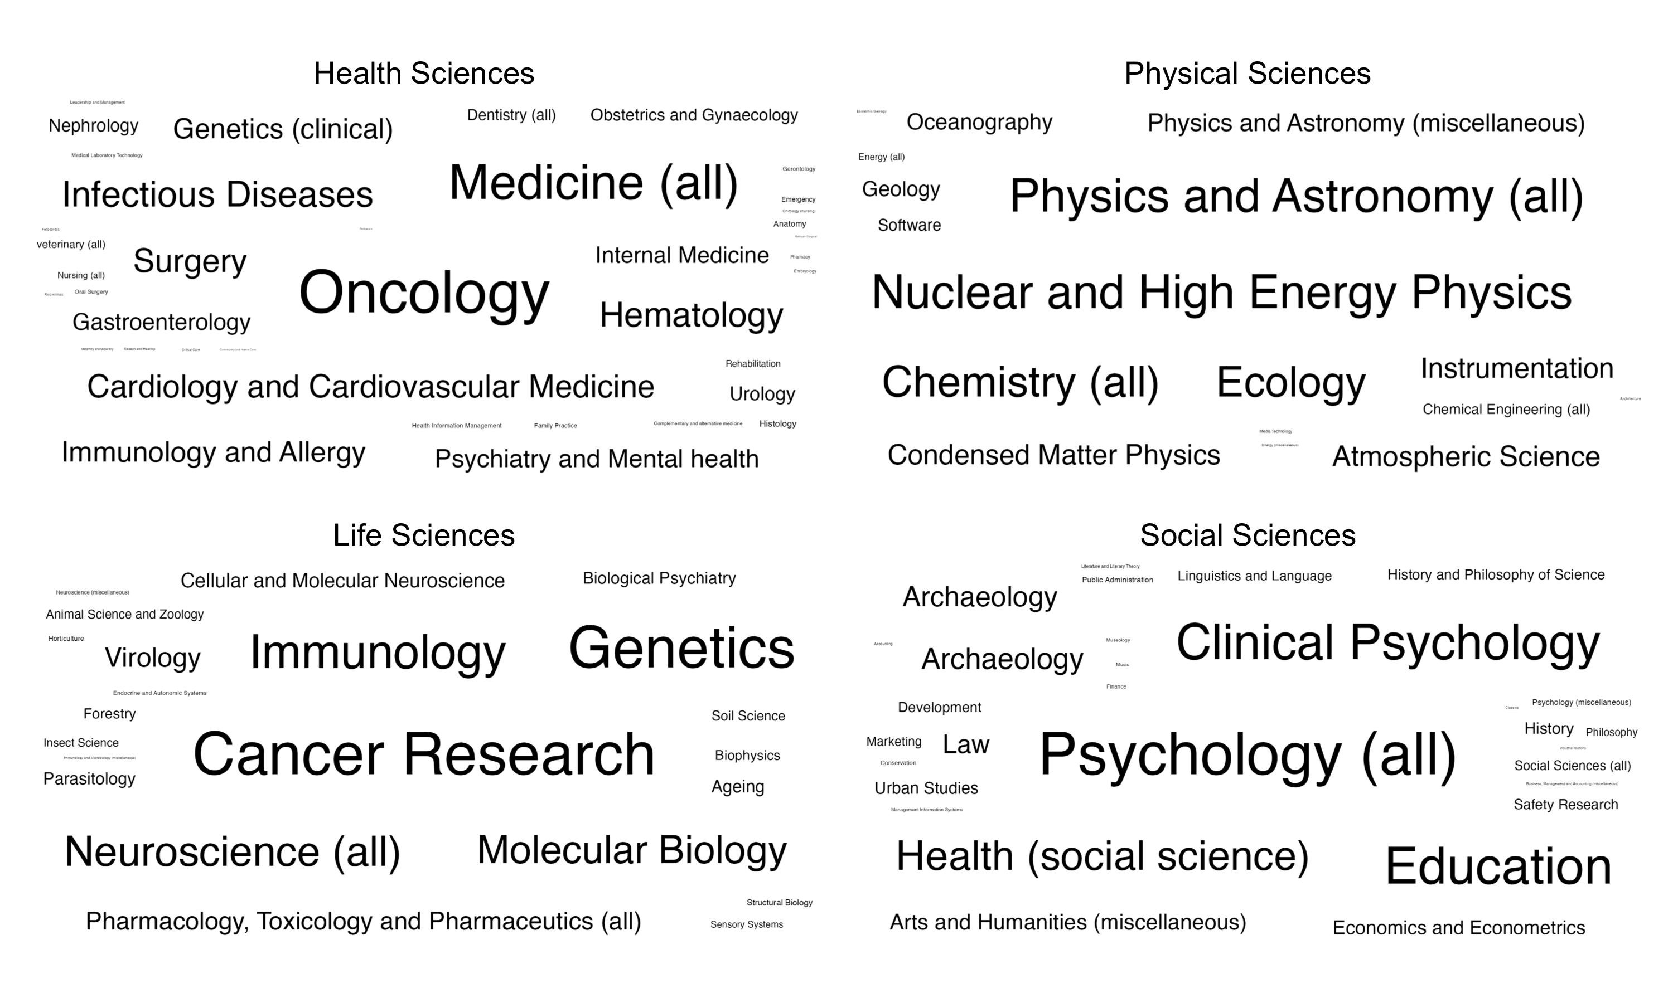

Figure 2: Journal Areas for Big-Team Science Publications by Subject Area. Larger words indicate more publications in those ASJC areas.

## RQ3: Author Descriptive Statistics

The total number of unique authors across all publications was 3047067. The mean number of authors per publication was *M* = 49.31 (*SD* = 212.98, *Med* = 18) with a range of 10 to 5568. The median and average number of authors by subject area are displayed in Figure 3. In general, the average and median number of authors increased over time, with the exception of the skew in the Physical Sciences. Interestingly, the effect in the Physical Sciences appears to be declining toward the general trends seen in other areas in the last few decades.

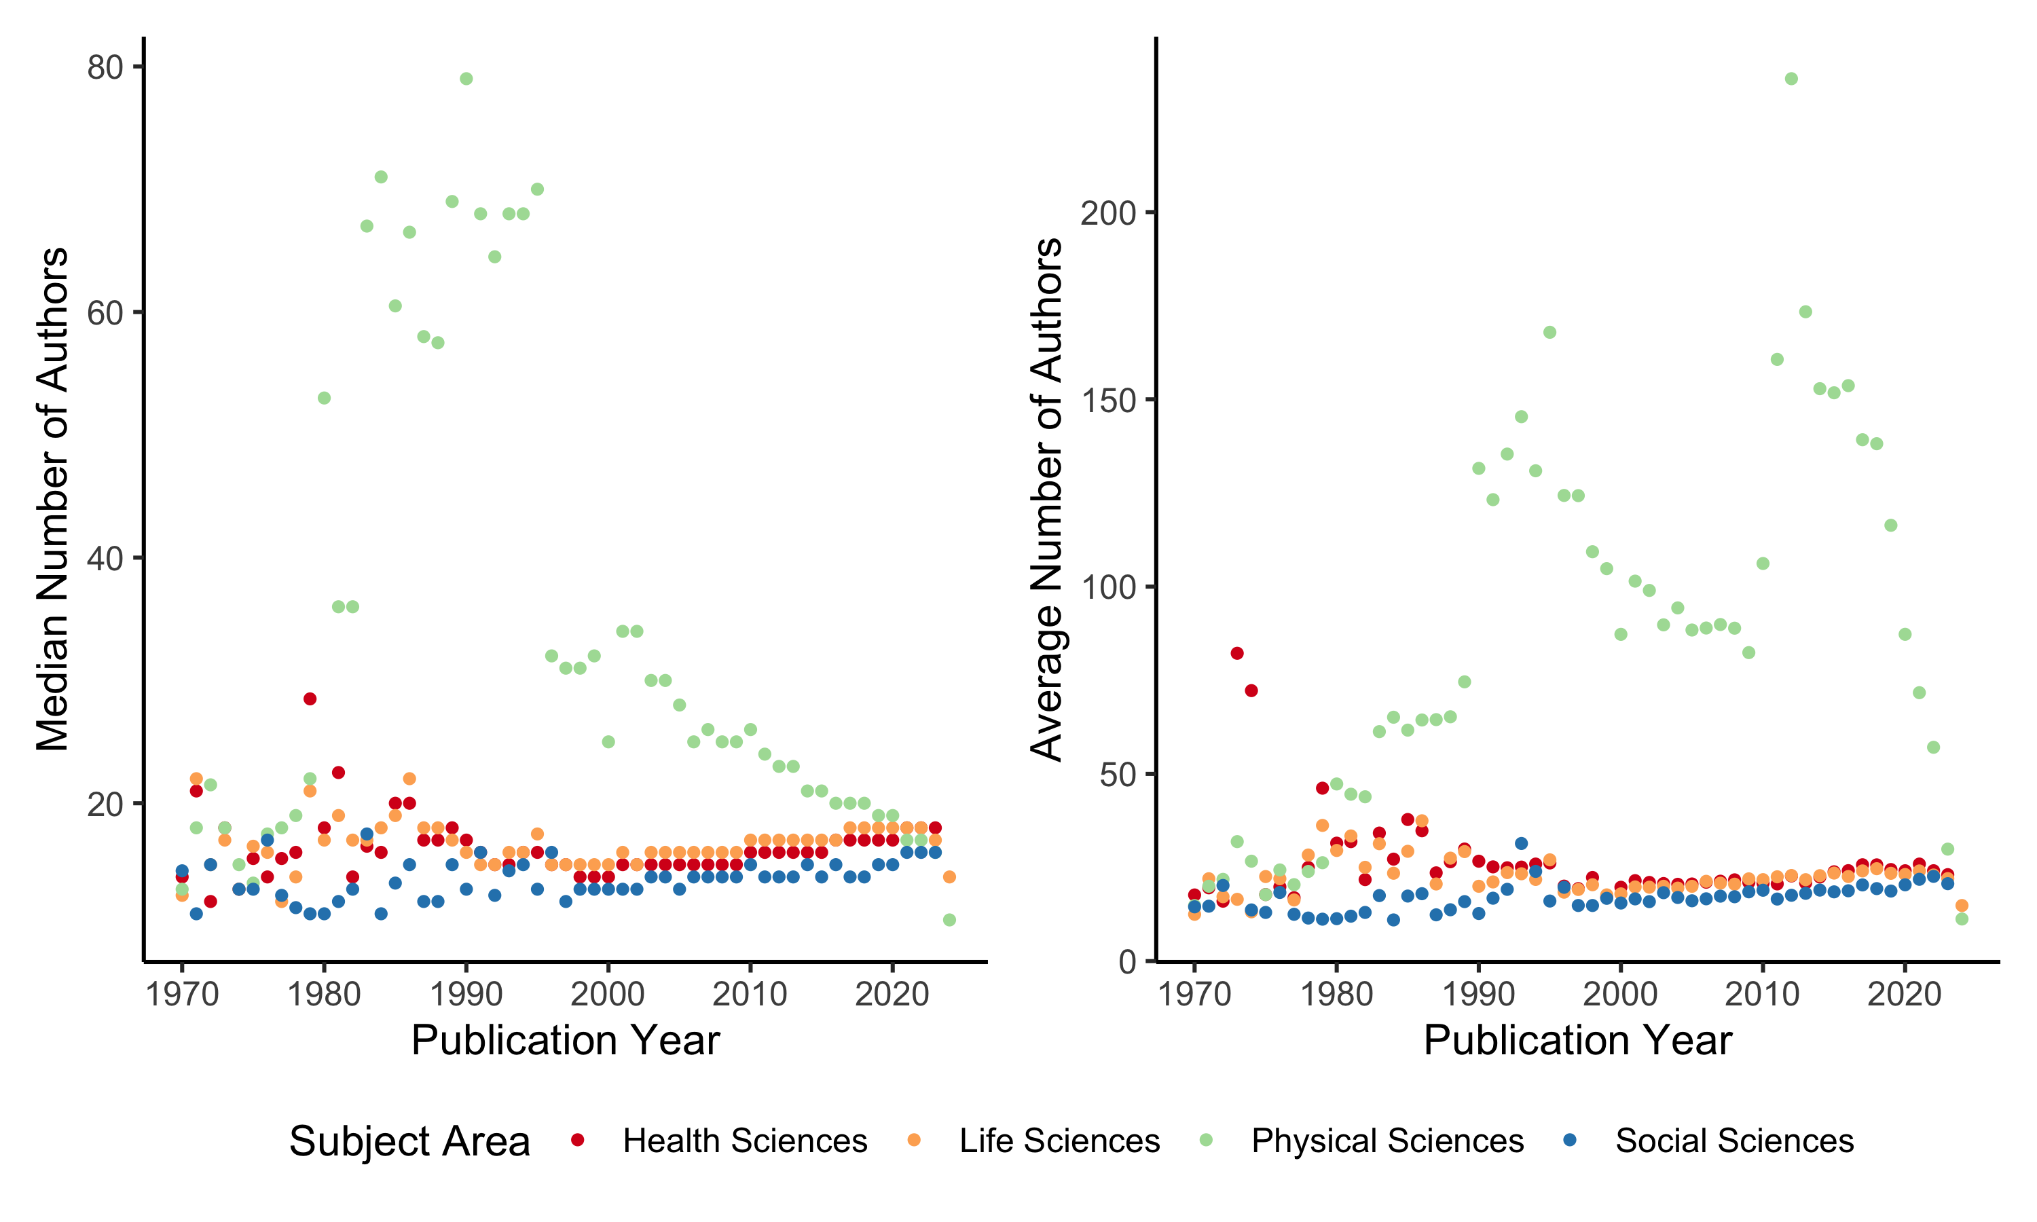

Figure 3: Number of authors included on big-team science papers per year by subject area. Given the large skew in the data, the left panel presents the median number of authors per manuscript, and the right panel presents the average number of authors per manuscript by year.

### Publication Metrics.

The average number of publications by authors on big team science papers is *M* = 38.37 (*SD* = 102.54). The publication counts were averaged across authors for each publication, and then these average publication counts were averaged across publications *M* = 162.50 (*SD* = 155.17). The average variability (i.e., the average standard deviation with authors of a manuscript) with publication counts of a paper was $M_{SD}$ = 164.27 ( $SD_{SD}$ = 127.21).

The same process was completed with *h*-index for each author and publication. The average *h*-index for authors overall was *M* = 33.65 (*SD* = 127.34, *Med* = 8.00). The average *h*-index for publications was *M* = 198.87 (*SD* = 248.78), and the variability of *h*-index across manuscripts was $M_{SD}$ = 211.80 ( $SD_{SD}$ = 238.53, $Med_{Med}$ = 68.00).

### Institutions.

The total number of unique affiliation across all papers was 463876.

## RQ4: Author Diversity Statistics

### Seniority.

Figure 4 portrays the average career length for authors involved in BTS publications across years. Career length was defined as the year of first publication minus the current year, and higher numbers mean longer careers. To analyze trends over time, we calculated the average career length for each publication (i.e., average author career lengths to create one score for each paper) and analyzed a regression analysis using career length to predict year of publication. In order to show variance between individuals, we calculated the standard deviation of career length for each publication and used this variance as an additional predictor.

Negative career length slopes would indicate more young scholars in later years (i.e., lower average career length as time increases). Positive career length slopes would indicate older scholars in later years (i.e., higher average career length as time increases). Negative career variance slopes imply that variability decreases over the years, so the average career length is more homogeneous. Positive career length slopes imply that variability increases over the years, so the average career length is varied across individuals (i.e., different stages of scholars). Figure 5 displays the results for all regression analyses to compare coefficient strength across and within each hypothesis.

All values for these analyses were different from zero. The slopes for the average career length were negative for all four subject areas, indicating a trend toward younger scientist involvement over time for each area, with the strongest effect in the Physical Sciences. The coefficient for variability in career length was also negative for each of the four subject areas with the highest in the Physical Sciences and lowest in the Life Sciences. This result indicates a decrease in the variability of career lengths over time, likely from two sources: 1) more publications with more authors, thus, lowering variance estimations, and 2) more young scholars overall. The effect sizes for this analysis were surprisingly large ranging from $R^{2}$ = .25 to .47. All values and their confidence intervals can be found on our OSF page.

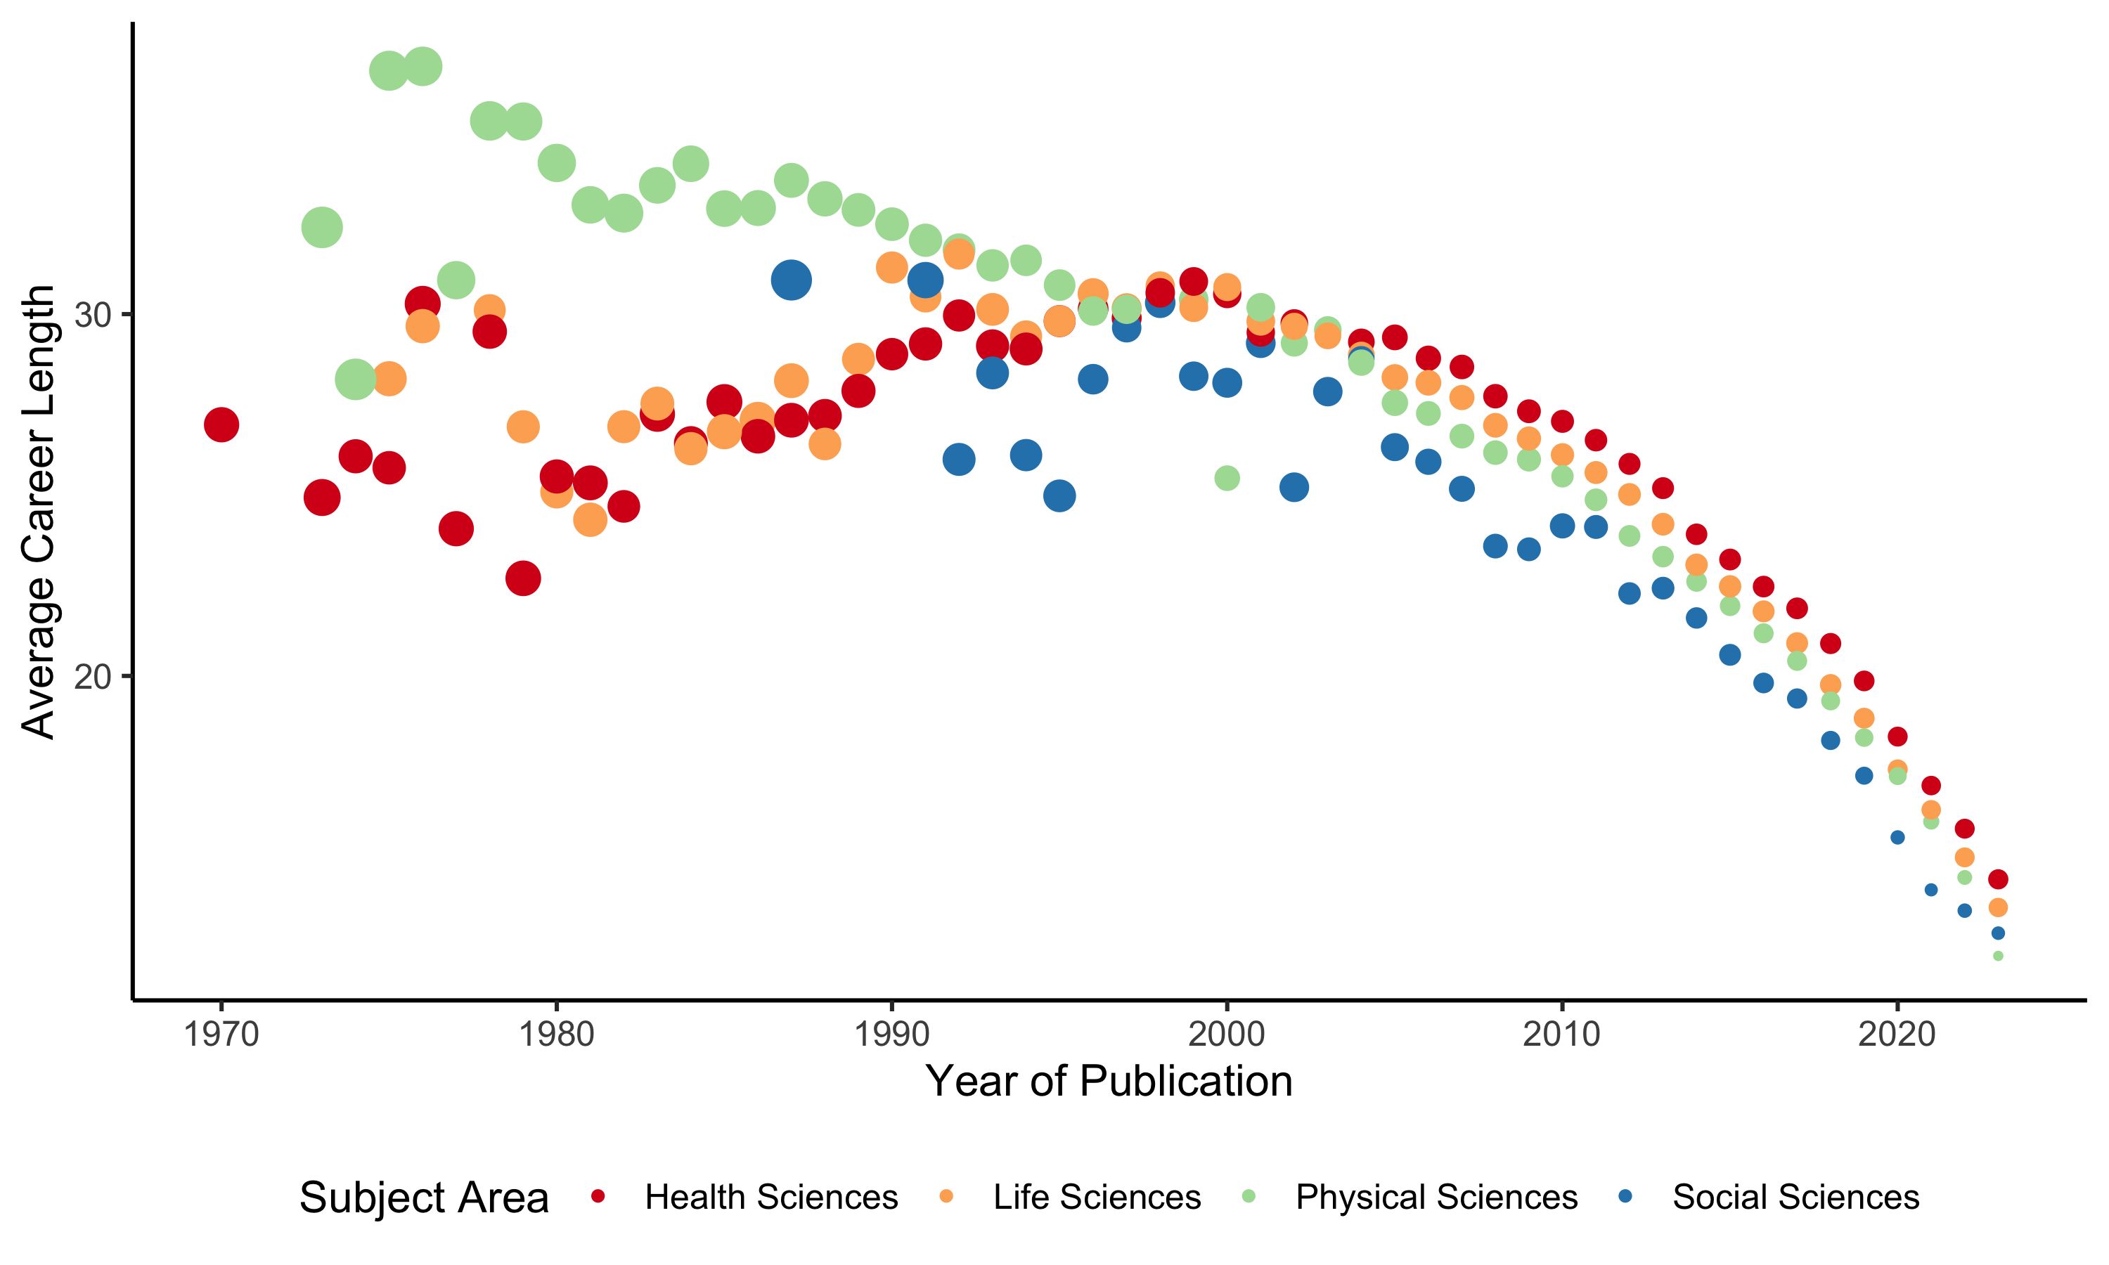

Figure 4: Average career length for big-team science authors. Larger dots indicate more variability in career length for authors by averaging the standard deviation in career length for each manuscript within a year. The data has been filtered to at least 10 publications in a year for this graph.

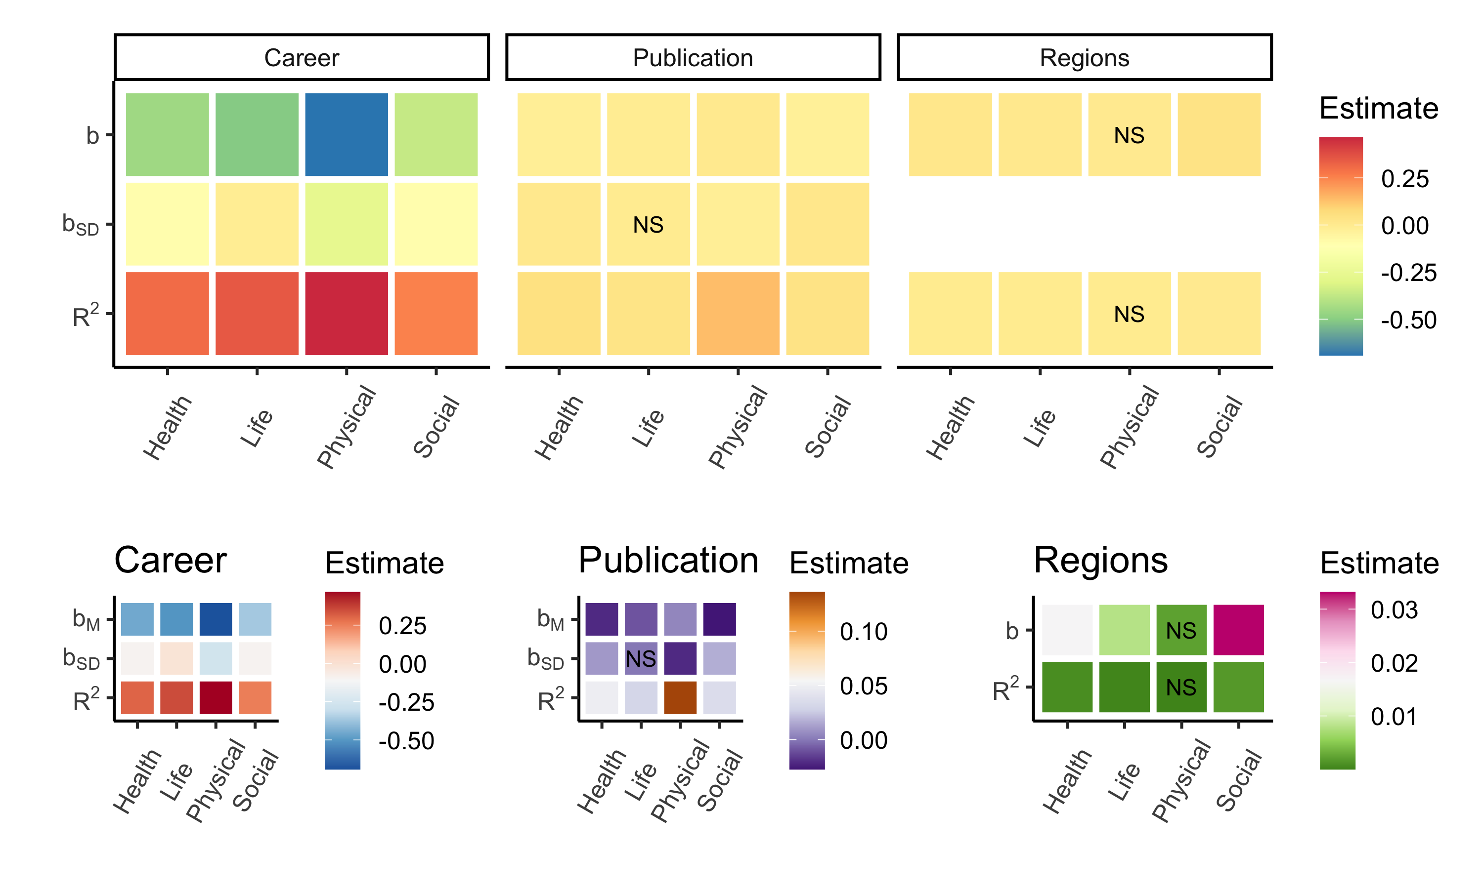

Figure 5: Heatmap results of regression analyses for career length, number of publications, and geopolitical diversity within the region. Each square represents a *b* value or the slope of the predictor (x-axis) onto the dependent variable (each panel), with the exception of the bottom row which is the effect size of each regression analysis $R^{2}$. Slopes included both the overall value of the predictor ($b$, $b_{M}$) and the standard deviation of the predictor over time ($b_{SD}$). The color of the square represents the strength of the predictor. The top figure represents all results together for comparison across analyses. The bottom row represents individual heatmaps for each hypothesis to distinguish small differences between subject areas for those research questions. Non-significant results are indicated with NS on the plot.

We used the same analyses using number of publications to represent diversity instead of career length. An increasing slope over time indicates that individuals who are publishing more are more represented in BTS over time (i.e., increasing numbers of scholars with higher publication rates), while a negative slope indicates more researchers with less publications. A positive slope for the standard deviation of publication metrics indicates increasing variance over time (i.e., more diversity in the individual publication rates), while a negative slope would indicate less diversity in researchers over time. While publication rates do not represent value as a researcher, they are often used in hiring and promotion decisions, and we used this variable as a proxy to gauge the diversity in scholars represented in big teams. As shown in Figure 5 publication metrics were generally negative for the average publication metrics, indicating more scholars over time with lower numbers of publications with the strongest effects in Health and Social Sciences. The variability of publication counts was not significant for the Life Sciences but was negative for the Physical Sciences (less variability over time) and positive for Social and Health Sciences (more variability and over time). This result indicates that the Physical Sciences are trending toward scholars with less publications but also less diverse in number of publications, while the Health and Social Sciences see more diversity in publication counts and less published scholars overall.

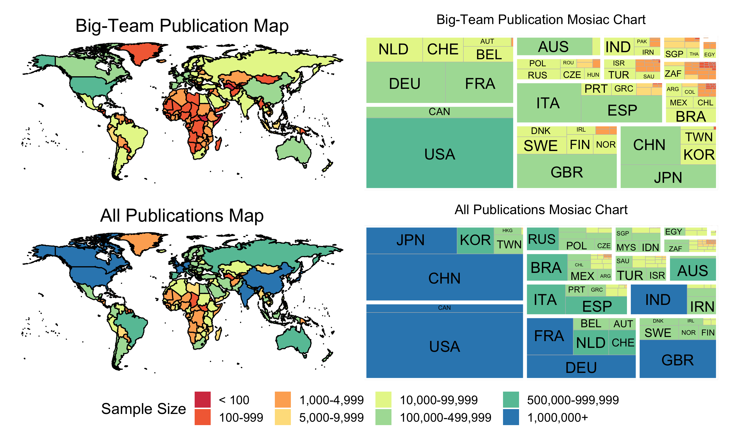

Figure 6: Geopolitical regions represented in big-team science publications versus all publications. The mosaic plot is grouped by UN subregion with the largest number of publications starting on the bottom left and smallest on the top right. Therefore, North America represents the largest number of authors within BTS (i.e., bottom right, then separated into the geopolitical areas within that subregion), followed by Eastern Europe (top left), and so on.

### Geopolitical Regions.

Author geopolitical region is displayed in Figure 6. Big team publications appear to be led by North America and Western Europe, while all publications are led by North America and East Asia. To understand the change in representation diversity, we examined if the number of regions in a publication is predicted by the year of publication. Increasing diversity would be represented by a positive slope, while decreasing diversity would be represented by a negative slope. As shown in Figure 5, the Physical Sciences do not show a trend of change in representation, while all other sciences showed a positive effect increasing in the number of geopolitical regions authors represent on publications.

Last, we examined the differences in representation for corresponding author sets versus all other authors. For papers with 10 to 49 authors, we used the three first authors and the last author to compare against other authors. For 50 to 99 authors, five first authors plus last were used, and for all papers with more than 100 authors, we used ten first authors and the last author as the corresponding author set. We then calculated the frequencies of each of the UN Sub-Regions for corresponding authors versus all other authors, converting these values to proportions. Given the expected small sample sizes of these contingency tables, we grouped together titles based on the year of publication. For each grouping, we then calculated the effect size of the differences in frequencies comparing corresponding authors to all other authors. Since this data is categorical, we used Cramer’s *V* to represent the effect size. If the effect size includes zero in its confidence interval (to four decimal places), this result will imply that first and all other authors represent the same pattern of UN Sub-Region diversity. Any confidence interval that does include zero represents a difference in diversity.

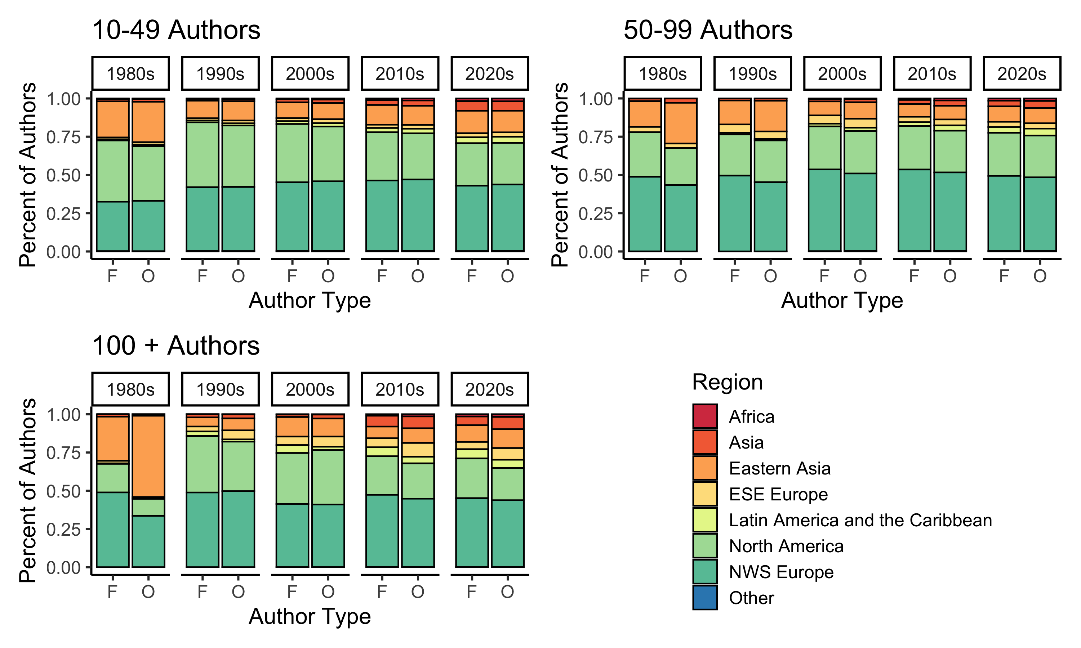

Figure 7: A comparison of author affiliation geopolitical regions across decades. F stands for first authors and O stands for other authors.

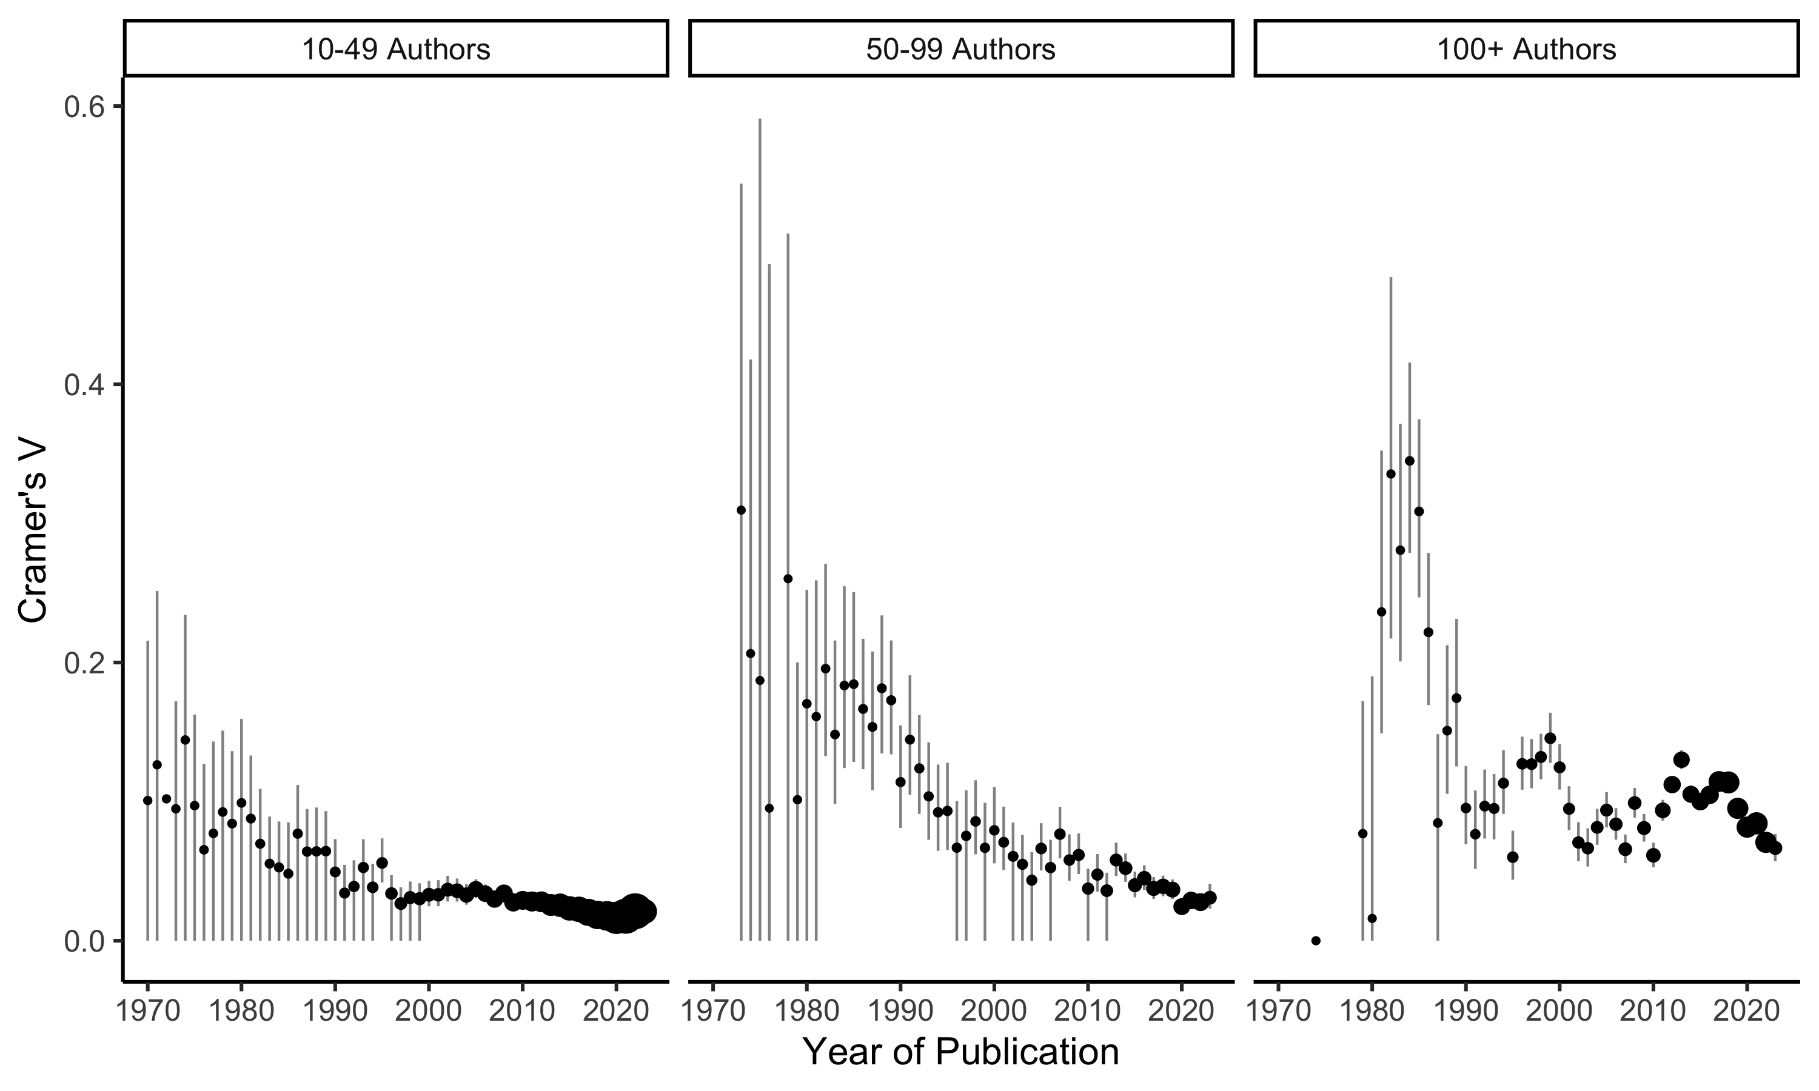

Figure 8: Effect size of the differences in representation for UN Regions for author affiliations in big-team science papers by year. Larger dots indicate more papers and authors represented in the calculation of effect size.

Figure 7 indicates the percent of authors in regions. In general, we found the same pattern as the overall analysis wherein most authors are from Europe and North America. The pattern of representation is roughly similar for the separation of small, medium, and large numbers of authors on papers. Across time, the representation does appear to diversify, with more representation in Asia, Latin American, and Africa. Figure 8 represents the size of the differences in first/corresponding authors and other authors across time and number of authors. The differences in representation are larger for papers with more authors; however, the effects are non-zero for many of the comparisons. Encouragingly, over time these effects appear to diminish in size. One limitation with the calculation of effect sizes for count data is the sensitivity of the data to sample size (i.e., $χ^{2}$ is upwardly biased by sample size, and $V$ is calculated based on this value). While we used the inclusion of zero as our boundary for “significance”, the interpretation of the effects is that most are likely small: $V$ < .05: 31.79%, $V$ < .10: 70.20%, $V$ < .20: 94.04%.

# Discussion

In this investigation, we explored the publication rates, areas, and researchers involved in big team science publications. Over a half-million articles were published in nearly 15,000 journals since 1970 that qualified as big team science articles (at least ten authors and ten different affiliations). The areas of publication were aligned to cancer and genetics research in medicine and oncology for Health and Life Sciences, physics and chemistry for the Physical Sciences, and psychology for the Social Sciences All areas of research show an explosion in growth in the number of publications and the number of authors included on manuscripts, replicating previous investigations into this topic area (Hunter & Leahey, 2008; Sinatra et al., 2015; Wuchty et al., 2007).

Our investigation expands into an exploration of the researchers who publish in big teams focusing on diversity in seniority of authors and geopolitical affiliation. The number of earlier career scholars is increasing in publications across the years, indicating that big teams may be more accessible to different types of individuals, not just older, more established researchers. This result is especially interesting given the publish-or-perish model still present in most institutions, as it may seem that large-scale projects could be a risky choice for non-permanent researchers. In the authors’ experience, big team projects are often quite slow to publication, incentives may be low for non corresponding authors if institutions do not value papers without lead authorship, and there is no guarantee for publication even with a large group. However, with a large team the distribution of work could imply less effort on individual non-leading members, and research has shown that larger-team publications do receive more citations and appear to have higher impact (Larivière et al., 2015).

The results for the number of publications by big team researchers mimics the findings from career length, with a smaller effect size. In general, it appears that there is a decrease in the average number of publications a researcher has when publishing on a big team science paper over time. This result is likely attributable to the number of early career scholars joining projects, but also may support increased accessibility for individuals to be involved in this type of research. Globalization, the internet, and the focus on interdisciplinary research are potentially driving forces behind our results, but, hopefully, the results also point to a decline in scientific gatekeeping (Lu, 2007; Siler et al., 2015).

The variability in the types of researchers involved in publications also decreased across time in most areas of science with a decrease in variability for career length. As mentioned, an increase in early career researchers and numbers of publications could explain this effect mathematically, potentially with other social influences mentioned above. The variability in the number of publications is decreasing in the Physical Sciences, mirroring the career length results, but the opposite effect was found in the Health and Social Sciences. We see no clear reason why career variability would decrease while the variability in the number of publications would increase. The effect sizes for career length were much larger than the effects for number of publications. One speculation is the increasing requirements for a competitive faculty role application. Given the limited number of positions, one potential way to distinguish their application would be a larger number of publications in their early career (Caplow, 2017; Kyvik, 2003).

The number of geopolitical entities for researcher affiliation is increasing over time, showing the results of globalization and the ability to connect across time zones and cultures (Xie, 2014). While our definition of big team science required at least ten different institutional affiliations, we did not filter papers by geopolitical region, and thus, a manuscript could rely solely on institutions within a single country. The Physical Sciences did not show an increase in diversity of regions represented, however, it could be argued that the development of large research centers like CERN forced earlier diversity than other sciences (i.e., because CERN specifically recruited scientists from sponsoring nations). The Life, Health, and Social Sciences saw an increase in the number of regions represented with the highest increase in the Social Sciences. This result likely corresponds with an increased interest in big team science publications in psychology (Coles et al., 2022; Forscher et al., 2022), and the desire to diversify the populations represented in psychological research (Henrich et al., 2010; Newson et al., 2021).

While publications on the whole are diversifying, we did not yet find equality in the representation for first/corresponding author spots versus all other authors. In general, first authors appear to be less diverse, representing more European and North American authors, while other authors include more Asian and African authors. These effect sizes were often small, but the inequality still persists across years, even if they are slowly decreasing. Diverse teams are more likely to have papers with stronger “impact” (Freeman & Huang, 2015; Hinnant et al., 2012; B. F. Jones et al., 2008; Yang et al., 2022) with higher citation metrics for more diverse author lists. The introduction of contributorship models (e.g., CRediT(Allen et al., 2019)) will hopefully continue to push these effects down, as they highlight each individual’s contribution to a manuscript.

The limitations for this research are tied to the availability and curation of the Scopus dataset. While the number of articles analyzed for this investigation was large, the criteria for inclusion requires the correct entry of author affiliations, the correct author linkages for career length and publication rates, and the correctly marked geopolitical entity. We had planned to analyze educational levels to determine if the number of student coauthors (i.e., non-terminal degree) had increased over time; however, this data was mostly blank within the Scopus archive. Scopus is a carefully curated dataset, but these limitations must be kept in mind when interpreting the results. Publication language diversity was not investigated, and a previous study indicates that the majority of publications in big databases are in English (Albarillo, 2014). Certainly, publications in non-English languages would improve the statistics on diversity in scientific publishing - but the English language barrier likely exists regardless of inclusion in databases (Meneghini & Packer, 2007; Ramírez-Castañeda, 2020).

Big teams have the ability to provide high-impact, important research within scientific publishing, and this report suggests a promising trend of increasing numbers of publications that include earlier career and more diverse scholars. These partnerships introduce new challenges to collaboration from interpersonal conflict, infrastructure, incentives, to international political situations (Forscher et al., 2022). Directed studies into ways to navigate these situations would be beneficial for policy makers at institutions, as well as lead teams who organize and complete these projects. The implications for retention and promotion processes across a broad span of regions should be explored to improve diversity with the understanding of the differential impact of incentives for participating in big team studies.

# References

A philosophical case for big physics. (2021). *Nature Physics*, *17*(6), 661–661. <https://doi.org/10.1038/s41567-021-01278-0>

Albarillo, F. (2014). Language in social science databases: English versus non-english articles in JSTOR and scopus. *Behavioral & Social Sciences Librarian*, *33*(2), 77–90. <https://doi.org/10.1080/01639269.2014.904693>

Allen, L., O’Connell, A., & Kiermer, V. (2019). How can we ensure visibility and diversity in research contributions? How the Contributor Role Taxonomy (CRediT) is helping the shift from authorship to contributorship. *Learned Publishing*, *32*(1), 71–74. <https://doi.org/10.1002/leap.1210>

Auspurg, K., & Brüderl, J. (2021). Has the Credibility of the Social Sciences Been Credibly Destroyed? Reanalyzing the “Many Analysts, One Data Set” Project. *Socius: Sociological Research for a Dynamic World*, *7*. <https://doi.org/10.1177/23780231211024421>

Bago, B., Kovacs, M., Protzko, J., Nagy, T., Kekecs, Z., Palfi, B., Adamkovic, M., Adamus, S., Albalooshi, S., Albayrak-Aydemir, N., Alfian, I. N., Alper, S., Alvarez-Solas, S., Alves, S. G., Amaya, S., Andresen, P. K., Anjum, G., Ansari, D., Arriaga, P., … Aczel, B. (2022). Situational factors shape moral judgements in the trolley dilemma in Eastern, Southern and Western countries in a culturally diverse sample. *Nature Human Behaviour*, *6*, 880–895. <https://doi.org/10.1038/s41562-022-01319-5>

Buchanan, E. M., Lewis, S. C., Paris, B., Forscher, P. S., Pavlacic, J. M., Beshears, J. E., Drexler, S. M., Gourdon-Kanhukamwe, A., Mallik, P. R., Silan, M. A. A., Miller, J. K., IJzerman, H., Moshontz, H., Beaudry, J. L., Suchow, J. W., Chartier, C. R., Coles, N. A., Sharifian, M., Todsen, A. L., … McFall, J. P. (2023). The psychological science accelerator’s COVID-19 rapid-response dataset. *Scientific Data*, *10*(1), 87. <https://doi.org/10.1038/s41597-022-01811-7>

Buttrick, N. R., Aczel, B., Aeschbach, L. F., Bakos, B. E., Brühlmann, F., Claypool, H. M., Hüffmeier, J., Kovacs, M., Schuepfer, K., Szecsi, P., Szuts, A., Szöke, O., Thomae, M., Torka, A.-K., Walker, R. J., & Wood, M. J. (2020). Many Labs 5: Registered Replication of Vohs and Schooler (2008), Experiment 1. *Advances in Methods and Practices in Psychological Science*, *3*(3), 429–438. <https://doi.org/10.1177/2515245920917931>

Caplow, T. (2017). *The academic marketplace* (2nd ed.). Routledge. <https://doi.org/10.4324/9781351305969>

Castelnovo, P., Florio, M., Forte, S., Rossi, L., & Sirtori, E. (2018). The economic impact of technological procurement for large-scale research infrastructures: Evidence from the Large Hadron Collider at CERN. *Research Policy*, *47*(9), 1853–1867. <https://doi.org/10.1016/j.respol.2018.06.018>

Coles, N. A., Hamlin, J. K., Sullivan, L. L., Parker, T. H., & Altschul, D. (2022). Build up big-team science. *Nature*, *601*(7894), 505–507. <https://doi.org/10.1038/d41586-022-00150-2>

Collins, F. S., Morgan, M., & Patrinos, A. (2003). The human genome project: Lessons from large-scale biology. *Science*, *300*(5617), 286–290. <https://doi.org/10.1126/science.1084564>

Dorison, C. A., Lerner, J. S., Heller, B. H., Rothman, A. J., Kawachi, I. I., Wang, K., Rees, V. W., Gill, B. P., Gibbs, N., Ebersole, C. R., Vally, Z., Tajchman, Z., Zsido, A. N., Zrimsek, M., Chen, Z., Ziano, I., Gialitaki, Z., Ceary, C. D., Lin, Y., … Coles, N. A. (2022). In COVID-19 Health Messaging, Loss Framing Increases Anxiety with Little-to-No Concomitant Benefits: Experimental Evidence from 84 Countries. *Affective Science*, *3*(3), 577–602. <https://doi.org/10.1007/s42761-022-00128-3>

Ebersole, C. R., Atherton, O. E., Belanger, A. L., Skulborstad, H. M., Allen, J. M., Banks, J. B., Baranski, E., Bernstein, M. J., Bonfiglio, D. B. V., Boucher, L., Brown, E. R., Budiman, N. I., Cairo, A. H., Capaldi, C. A., Chartier, C. R., Chung, J. M., Cicero, D. C., Coleman, J. A., Conway, J. G., … Nosek, B. A. (2016). Many Labs 3: Evaluating participant pool quality across the academic semester via replication. *Journal of Experimental Social Psychology*, *67*, 68–82. <https://doi.org/10.1016/j.jesp.2015.10.012>

Ebersole, C. R., Mathur, M. B., Baranski, E., Bart-Plange, D.-J., Buttrick, N. R., Chartier, C. R., Corker, K. S., Corley, M., Hartshorne, J. K., IJzerman, H., Lazarević, L. B., Rabagliati, H., Ropovik, I., Aczel, B., Aeschbach, L. F., Andrighetto, L., Arnal, J. D., Arrow, H., Babincak, P., … Nosek, B. A. (2020). Many Labs 5: Testing Pre-Data-Collection Peer Review as an Intervention to Increase Replicability. *Advances in Methods and Practices in Psychological Science*, *3*(3), 309–331. <https://doi.org/10.1177/2515245920958687>

Errington, T. M., Mathur, M., Soderberg, C. K., Denis, A., Perfito, N., Iorns, E., & Nosek, B. A. (2021). Investigating the replicability of preclinical cancer biology. *eLife*, *10*, e71601. <https://doi.org/10.7554/eLife.71601>

Forscher, P. S., Wagenmakers, E.-J., Coles, N. A., Silan, M. A., Dutra, N., Basnight-Brown, D., & IJzerman, H. (2022). The Benefits, Barriers, and Risks of Big-Team Science. *Perspectives on Psychological Science*, *18*(3), 607623. <https://doi.org/10.1177/17456916221082970>

Franco, A., Malhotra, N., & Simonovits, G. (2014). Publication bias in the social sciences: Unlocking the file drawer. *Science*, *345*(6203), 1502–1505. <https://doi.org/10.1126/science.1255484>

Freeman, R. B., & Huang, W. (2015). Collaborating with People Like Me: Ethnic Coauthorship within the United States. *Journal of Labor Economics*, *33*(S1), S289–S318. <https://doi.org/10.1086/678973>

Grahe, J. E. (2014). Announcing open science badges and reaching for the sky. *The Journal of Social Psychology*, *154*(1), 1–3. <https://doi.org/10.1080/00224545.2014.853582>

Henrich, J., Heine, S. J., & Norenzayan, A. (2010). The weirdest people in the world? *Behavioral and Brain Sciences*, *33*(2-3), 61–83. <https://doi.org/10.1017/S0140525X0999152X>

Hinnant, C. C., Stvilia, B., Wu, S., Worrall, A., Burnett, G., Burnett, K., Kazmer, M. M., & Marty, P. F. (2012). Author-team diversity and the impact of scientific publications: Evidence from physics research at a national science lab. *Library & Information Science Research*, *34*(4), 249–257. <https://doi.org/10.1016/j.lisr.2012.03.001>

Hubbard, R., & Armstrong, J. S. (1997). Publication Bias against Null Results. *Psychological Reports*, *80*(1), 337–338. <https://doi.org/10.2466/pr0.1997.80.1.337>

Hunter, L., & Leahey, E. (2008). Collaborative Research in Sociology: Trends and Contributing Factors. *The American Sociologist*, *39*(4), 290–306. <https://doi.org/10.1007/s12108-008-9042-1>

Isager, P. M., Van Aert, R. C. M., Bahník, Š., Brandt, M. J., DeSoto, K. A., Giner-Sorolla, R., Krueger, J. I., Perugini, M., Ropovik, I., Van ’T Veer, A. E., Vranka, M., & Lakens, D. (2023). Deciding what to replicate: A decision model for replication study selection under resource and knowledge constraints. *Psychological Methods*, *28*(2), 438–451. <https://doi.org/10.1037/met0000438>

Isager, P. M., van ’t Veer, A. E., & Lakens, D. (2021). *Replication value as a function of citation impact and sample size*. <https://doi.org/10.31222/osf.io/knjea>

John, L. K., Loewenstein, G., & Prelec, D. (2012). Measuring the Prevalence of Questionable Research Practices With Incentives for Truth Telling. *Psychological Science*, *23*(5), 524–532. <https://doi.org/10.1177/0956797611430953>

Jones, B. C., DeBruine, L. M., Flake, J. K., Liuzza, M. T., Antfolk, J., Arinze, N. C., Ndukaihe, I. L. G., Bloxsom, N. G., Lewis, S. C., Foroni, F., Willis, M. L., Cubillas, C. P., Vadillo, M. A., Turiegano, E., Gilead, M., Simchon, A., Saribay, S. A., Owsley, N. C., Jang, C., … Coles, N. A. (2021). To which world regions does the valencedominance model of social perception apply? *Nature Human Behaviour*, *5*(1), 159–169. <https://doi.org/10.1038/s41562-020-01007-2>

Jones, B. F., Wuchty, S., & Uzzi, B. (2008). Multi-university research teams: Shifting impact, geography, and stratification in science. *Science*, *322*(5905), 1259–1262. <https://doi.org/10.1126/science.1158357>

Kidwell, M. C., Lazarević, L. B., Baranski, E., Hardwicke, T. E., Piechowski, S., Falkenberg, L.-S., Kennett, C., Slowik, A., Sonnleitner, C., Hess-Holden, C., Errington, T. M., Fiedler, S., & Nosek, B. A. (2016). Badges to Acknowledge Open Practices: A Simple, Low-Cost, Effective Method for Increasing Transparency. *PLOS Biology*, *14*(5), e1002456. <https://doi.org/10.1371/journal.pbio.1002456>

Klein, R. A., Cook, C. L., Ebersole, C. R., Vitiello, C., Nosek, B. A., Hilgard, J., Ahn, P. H., Brady, A. J., Chartier, C. R., Christopherson, C. D., Clay, S., Collisson, B., Crawford, J. T., Cromar, R., Gardiner, G., Gosnell, C. L., Grahe, J., Hall, C., Howard, I., … Ratliff, K. A. (2022). Many Labs 4: Failure to Replicate Mortality Salience Effect With and Without Original Author Involvement. *Collabra: Psychology*, *8*(1), 35271. <https://doi.org/10.1525/collabra.35271>

Klein, R. A., Vianello, M., Hasselman, F., Adams, B. G., Adams, R. B., Alper, S., Aveyard, M., Axt, J. R., Babalola, M. T., Bahník, Š., Batra, R., Berkics, M., Bernstein, M. J., Berry, D. R., Bialobrzeska, O., Binan, E. D., Bocian, K., Brandt, M. J., Busching, R., … Nosek, B. A. (2018). Many Labs 2: Investigating Variation in Replicability Across Samples and Settings. *Advances in Methods and Practices in Psychological Science*, *1*(4), 443–490. <https://doi.org/10.1177/2515245918810225>

Kyvik, S. (2003). Changing trends in publishing behaviour among university faculty, 1980-2000. *Scientometrics*, *58*(1), 35–48. <https://doi.org/10.1023/A:1025475423482>

Larivière, V., Gingras, Y., Sugimoto, C. R., & Tsou, A. (2015). Team size matters: Collaboration and scientific impact since 1900. *Journal of the Association for Information Science and Technology*, *66*(7), 1323–1332. <https://doi.org/10.1002/asi.23266>

LeBel, E. P., McCarthy, R. J., Earp, B. D., Elson, M., & Vanpaemel, W. (2018). A Unified Framework to Quantify the Credibility of Scientific Findings. *Advances in Methods and Practices in Psychological Science*, *1*(3), 389–402. <https://doi.org/10.1177/2515245918787489>

Lu, Y. (2007). The human in human information acquisition: Understanding gatekeeping and proposing new directions in scholarship. *Library & Information Science Research*, *29*(1), 103–123. <https://doi.org/10.1016/j.lisr.2006.10.007>

Maizey, L., & Tzavella, L. (2019). Barriers and solutions for early career researchers in tackling the reproducibility crisis in cognitive neuroscience. *Cortex*, *113*, 357–359. <https://doi.org/10.1016/j.cortex.2018.12.015>

Mathur, M. B., Bart-Plange, D.-J., Aczel, B., Bernstein, M. H., Ciunci, A. M., Ebersole, C. R., Falcão, F., Ashbaugh, K., Hilliard, R. A., Jern, A., Kellier, D. J., Kessinger, G., Kolb, V. S., Kovacs, M., Lage, C. A., Langford, E. V., Lins, S., Manfredi, D., Meyet, V., … Frank, M. C. (2020). Many Labs 5: Registered Multisite Replication of the Tempting-Fate Effects in Risen and Gilovich (2008). *Advances in Methods and Practices in Psychological Science*, *3*(3), 394–404. <https://doi.org/10.1177/2515245918785165>

Maxwell, S. E., Lau, M. Y., & Howard, G. S. (2015). Is psychology suffering from a replication crisis?: What does ’failure to replicate’ really mean? *American Psychologist*, *70*(6), 487–498. <https://doi.org/10.1037/a0039400>

Mayo-Wilson, E., Grant, S., Supplee, L., Kianersi, S., Amin, A., DeHaven, A., & Mellor, D. (2021). Evaluating implementation of the transparency and openness promotion (TOP) guidelines: The TRUST process for rating journal policies, procedures, and practices. *Research Integrity and Peer Review*, *6*(1), 9. <https://doi.org/10.1186/s41073-021-00112-8>

Meneghini, R., & Packer, A. L. (2007). Is there science beyond english? *EMBO Reports*, *8*(2), 112–116. <https://doi.org/10.1038/sj.embor.7400906>

Moshontz, H., Campbell, L., Ebersole, C. R., IJzerman, H., Urry, H. L., Forscher, P. S., Grahe, J. E., McCarthy, R. J., Musser, E. D., Antfolk, J., Castille, C. M., Evans, T. R., Fiedler, S., Flake, J. K., Forero, D. A., Janssen, S. M. J., Keene, J. R., Protzko, J., Aczel, B., … Chartier, C. R. (2018). The Psychological Science Accelerator: Advancing Psychology Through a Distributed Collaborative Network. *Advances in Methods and Practices in Psychological Science*, *1*(4), 501–515. <https://doi.org/10.1177/2515245918797607>

Nelson, L. D., Simmons, J., & Simonsohn, U. (2018). Psychology’s renaissance. *Annual Review of Psychology*, *69*(1), 511–534. <https://doi.org/10.1146/annurev-psych-122216-011836>

Newson, M., Buhrmester, M., Xygalatas, D., & Whitehouse, H. (2021). Go WILD, not WEIRD. *Journal for the Cognitive Science of Religion*, *6*(1-2). <https://doi.org/10.1558/jcsr.38413>

Nosek, B. A., Alter, G., Banks, G. C., Borsboom, D., Bowman, S. D., Breckler, S. J., Buck, S., Chambers, C. D., Chin, G., Christensen, G., Contestabile, M., Dafoe, A., Eich, E., Freese, J., Glennerster, R., Goroff, D., Green, D. P., Hesse, B., Humphreys, M., … Yarkoni, T. (2015). Promoting an open research culture. *Science*, *348*(6242), 1422–1425. <https://doi.org/10.1126/science.aab2374>

Nosek, B. A., & Lakens, D. (2014a). A method to increase the credibility of published results. *Social Psychology*, *45*(3), 137141.

Nosek, B. A., & Lakens, D. (2014b). Registered Reports: A Method to Increase the Credibility of Published Results. *Social Psychology*, *45*(3), 137–141. <https://doi.org/10.1027/1864-9335/a000192>

Nosek, B. A., Spies, J. R., & Motyl, M. (2012). Scientific Utopia: II. Restructuring Incentives and Practices to Promote Truth Over Publishability. *Perspectives on Psychological Science*, *7*(6), 615–631. <https://doi.org/10.1177/1745691612459058>

OED. (2016). *Collaboration* (Vol. 3). Oxford University.

Open Science Collaboration. (2015). Estimating the reproducibility of psychological science. *Science*, *349*(6251), aac4716–aac4716. <https://doi.org/10.1126/science.aac4716>

Psychological Science Accelerator Self-Determination Theory Collaboration. (2022). A global experiment on motivating social distancing during the COVID-19 pandemic. *Proceedings of the National Academy of Sciences*, *119*(22), e2111091119. <https://doi.org/10.1073/pnas.2111091119>

Rad, M. S., Martingano, A. J., & Ginges, J. (2018). Toward a psychology of homo sapiens: Making psychological science more representative of the human population. *Proceedings of the National Academy of Sciences*, *115*(45), 11401–11405. <https://doi.org/10.1073/pnas.1721165115>

Ramírez-Castañeda, V. (2020). Disadvantages in preparing and publishing scientific papers caused by the dominance of the English language in science: The case of Colombian researchers in biological sciences. *PLOS ONE*, *15*(9), e0238372. <https://doi.org/10.1371/journal.pone.0238372>

Silberzahn, R., Uhlmann, E. L., Martin, D. P., Anselmi, P., Aust, F., Awtrey, E., Bahník, Š., Bai, F., Bannard, C., Bonnier, E., & others. (2018). Many analysts, one data set: Making transparent how variations in analytic choices affect results. *Advances in Methods and Practices in Psychological Science*, *1*(3), 337356.

Siler, K., Lee, K., & Bero, L. (2015). Measuring the effectiveness of scientific gatekeeping. *Proceedings of the National Academy of Sciences*, *112*(2), 360–365. <https://doi.org/10.1073/pnas.1418218112>

Sinatra, R., Deville, P., Szell, M., Wang, D., & Barabási, A.-L. (2015). A century of physics. *Nature Physics*, *11*(10), 791–796. <https://doi.org/10.1038/nphys3494>

Skorb, L., Aczel, B., Bakos, B. E., Feinberg, L., Hałasa, E., Kauff, M., Kovacs, M., Krasuska, K., Kuchno, K., Manfredi, D., Montealegre, A., Pękala, E., Pieńkosz, D., Ravid, J., Rentzsch, K., Szaszi, B., Schulz-Hardt, S., Sioma, B., Szecsi, P., … Hartshorne, J. K. (2020). Many Labs 5: Replication of van Dijk, van Kleef, Steinel, and van Beest (2008). *Advances in Methods and Practices in Psychological Science*, *3*(3), 418–428. <https://doi.org/10.1177/2515245920927643>

Stewart, N., Chandler, J., & Paolacci, G. (2017). Crowdsourcing samples in cognitive science. *Trends in Cognitive Sciences*, *21*(10), 736–748. <https://doi.org/10.1016/j.tics.2017.06.007>

Stewart, S., Rinke, E. M., McGarrigle, R., Lynott, D., Lunny, C., Lautarescu, A., Galizzi, M. M., Farran, E. K., & Crook, Z. (2020). *Pre-registration and registered reports: A primer from UKRN*. <https://doi.org/10.31219/osf.io/8v2n7>

Van Bavel, J. J., Cichocka, A., Capraro, V., Sjåstad, H., Nezlek, J. B., Pavlović, T., Alfano, M., Gelfand, M. J., Azevedo, F., Birtel, M. D., Cislak, A., Lockwood, P. L., Ross, R. M., Abts, K., Agadullina, E., Aruta, J. J. B., Besharati, S. N., Bor, A., Choma, B. L., … Boggio, P. S. (2022). National identity predicts public health support during a global pandemic. *Nature Communications*, *13*(1), 517. <https://doi.org/10.1038/s41467-021-27668-9>

Vazire, S., Schiavone, S. R., & Bottesini, J. G. (2022). Credibility Beyond Replicability: Improving the Four Validities in Psychological Science. *Current Directions in Psychological Science*, *31*(2), 162–168. <https://doi.org/10.1177/09637214211067779>

Wang, K., Goldenberg, A., Dorison, C. A., Miller, J. K., Uusberg, A., Lerner, J. S., Gross, J. J., Agesin, B. B., Bernardo, M., Campos, O., Eudave, L., Grzech, K., Ozery, D. H., Jackson, E. A., Garcia, E. O. L., Drexler, S. M., Jurković, A. P., Rana, K., Wilson, J. P., … Moshontz, H. (2021). A multi-country test of brief reappraisal interventions on emotions during the COVID-19 pandemic. *Nature Human Behaviour*, *5*(8), 1089–1110. <https://doi.org/10.1038/s41562-021-01173-x>

Wuchty, S., Jones, B. F., & Uzzi, B. (2007). The increasing dominance of teams in production of knowledge. *Science*, *316*(5827), 1036–1039. <https://doi.org/10.1126/science.1136099>

Xie, Y. (2014). “Undemocracy”: Inequalities in science. *Science*, *344*(6186), 809–810. <https://doi.org/10.1126/science.1252743>

Yang, Y., Tian, T. Y., Woodruff, T. K., Jones, B. F., & Uzzi, B. (2022). Gender-diverse teams produce more novel and higher-impact scientific ideas. *Proceedings of the National Academy of Sciences*, *119*(36), e2200841119. <https://doi.org/10.1073/pnas.2200841119>

Zwaan, R. A., Etz, A., Lucas, R. E., & Donnellan, M. B. (2018). Making replication mainstream. *Behavioral and Brain Sciences*, *41*, e120. <https://doi.org/10.1017/S0140525X17001972>

# (APPENDIX) Appendix

# Supplemental Materials

## RQ1: Publisher Information.

### Number of Journals.

Table 1 indicates the SNIP values for BTS publications, while Table 2. The results from these tables indicate that impact values are slightly higher for BTS publications, while the overall median, minimum, and maximum are the same for each grouping.

Table   
 *Big-Team Science SNIP Values*

| Subject Area | M | SD | Minimum | Median | Maximum |
| --- | --- | --- | --- | --- | --- |
| Health Sciences | 2.36 | 3.59 | 0.00 | 1.58 | 173.93 |
| Physical Sciences | 1.57 | 1.17 | 0.00 | 1.27 | 30.40 |
| Social Sciences | 1.94 | 1.72 | 0.00 | 1.52 | 30.40 |
| Life Sciences | 2.02 | 1.60 | 0.00 | 1.51 | 19.07 |

Table   
 *All Journal Articles SNIP Values*

| Subject Area | M | SD | Minimum | Median | Maximum |
| --- | --- | --- | --- | --- | --- |
| Health Sciences | 1.45 | 2.87 | 0.00 | 1.15 | 173.93 |
| Physical Sciences | 1.08 | 0.77 | 0.00 | 0.97 | 30.40 |
| Social Sciences | 1.32 | 1.03 | 0.00 | 1.15 | 30.40 |
| Life Sciences | 1.19 | 0.86 | 0.00 | 1.06 | 19.07 |

## RQ2: Publication Information.

### Keywords.

Figure 9 indicates the most common keywords present for the BTS publications by subject area. The keywords were tokenized into single tokens. Keywords were then lower cased, and all stop words (for example, the, an, of, into, for) were removed. Finally, a frequency count of tokens was tabulated for each subject area, and this count is used to create the final word cloud presented.

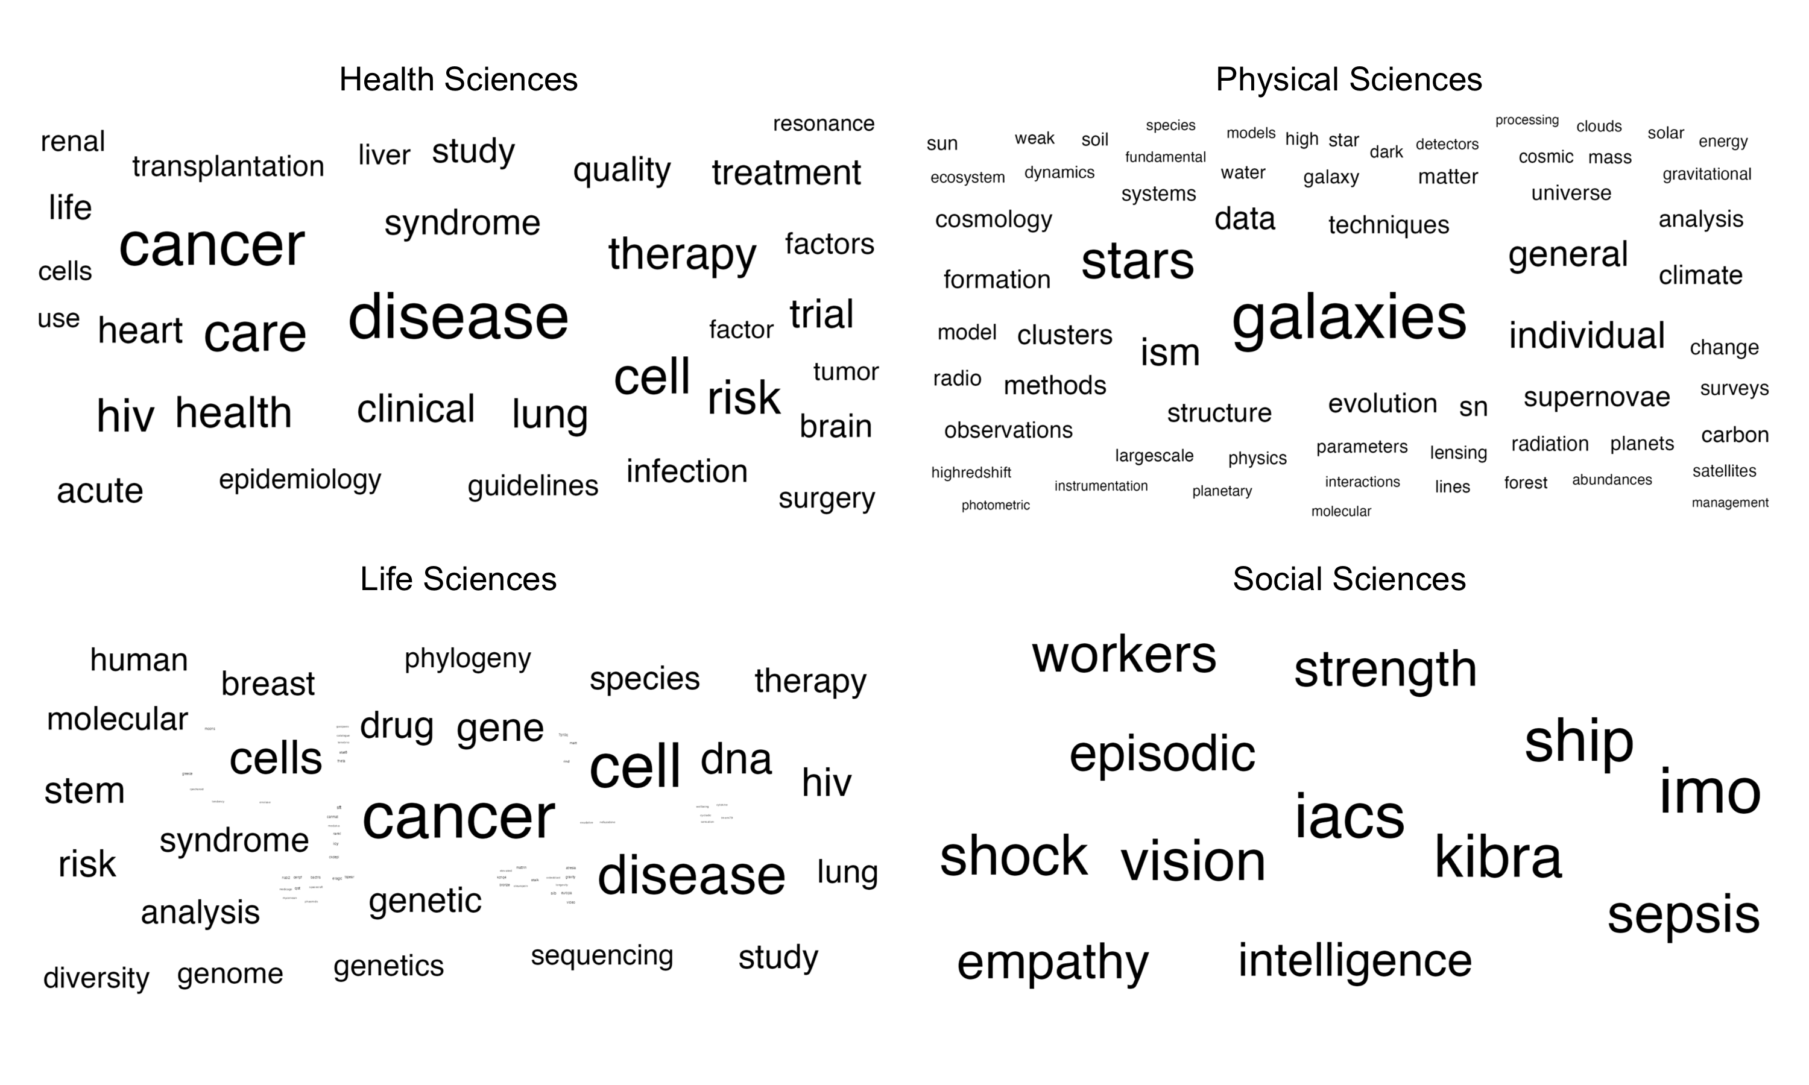

Figure 9: Keyword Analysis for Each of the Four Subject Areas.

## RQ3: Authors

### Institution.

Institution was normalized by taking the total number of unique institutions and dividing by the total number of institution listings. The patterns are similar for each decade in that papers are often either half unique institutions or mostly unique institutions overall as shown in Figure 10.

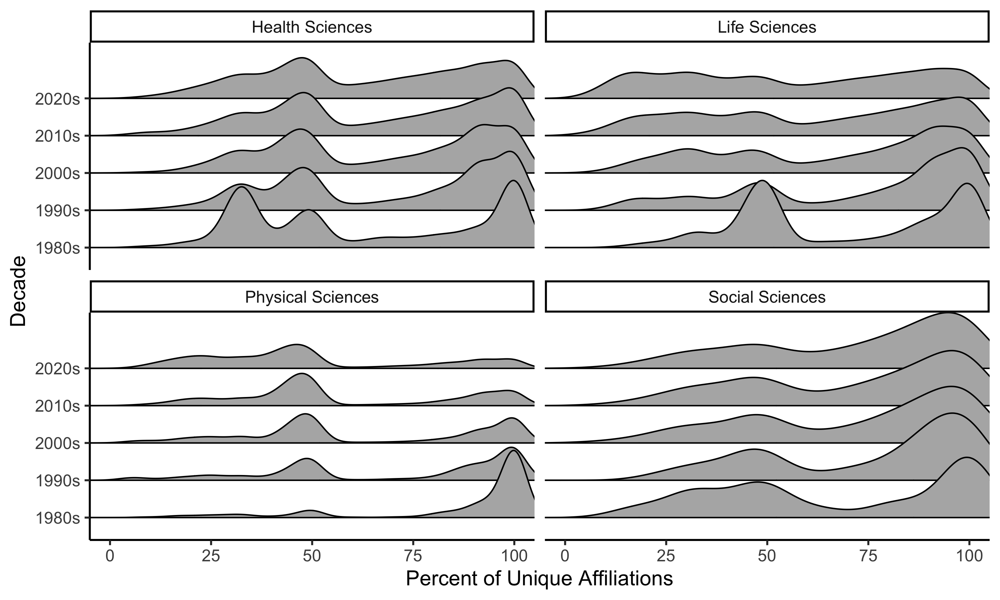

Figure 10: Number of unique institutions involved in big-team science papers across decades.

### Education.

As noted in our pre-registration, we would only present this variable if we could obtain at least 50% information on the authors who publish in big team science papers. 95.83% of the data was not available.

### Types of Publications.

Types of publications are presented in Figure 11. The patterns of publications are roughly similar for big team science authors and all authors. It appears that proportionally, big team members are more likely to post preprints in comparison to all authors.

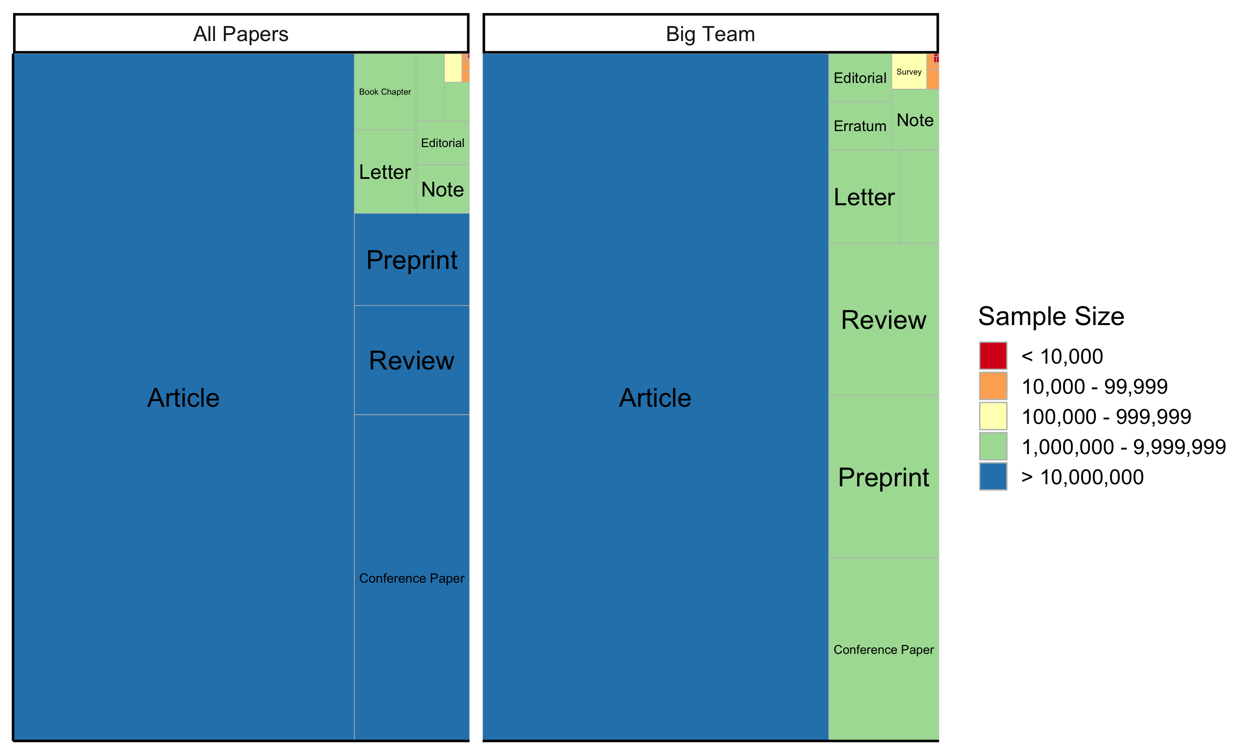

Figure 11: Types of publications for big-team science and all authors.

1. Unfortunately, the way we created these pre-registrations did not allow for complete anonymization required by the journal